AIM 7:- Performing one-way ANOVA using aov() (R).
OUTPUT
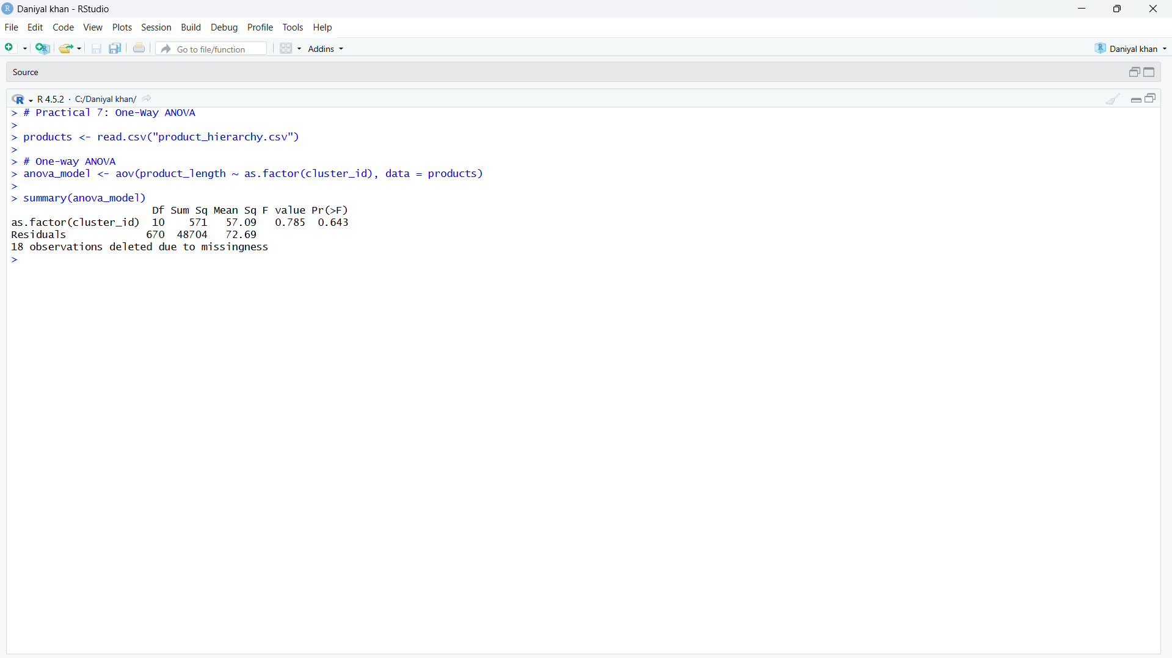

AIM 8:- Performing two-way ANOVA using aov() (R).
OUTPUT
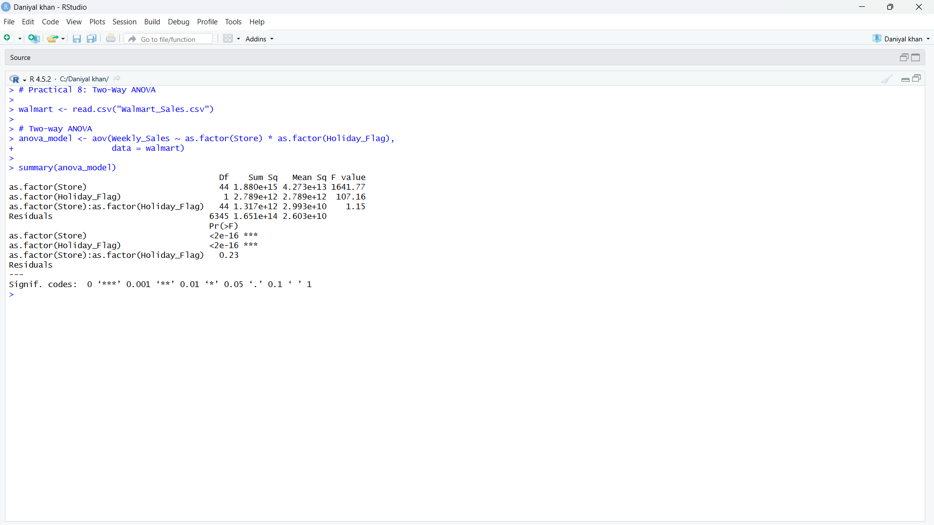
AIM9:- Conducting Chi-square tests using chisq.test() (R) .
OUTPUT
